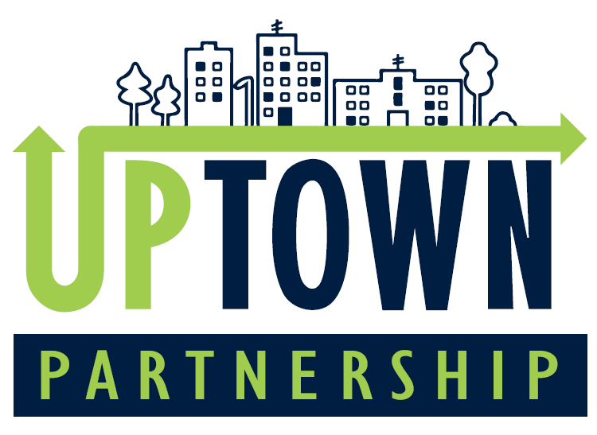

Uptown Partnership’s
Facade Improvement Grant Program Overview

Objective:
The Facade Improvement Grant Program is designed to stimulate investment in the exterior appearance of commercial and mixed-use properties within Uptown Martinsville. The program aims to enhance the aesthetic appeal, improve the marketability of the area, and preserve the historic character of our community.

Grant Amount:
Eligible applicants can receive up to $5,000 in grant funding, with a required 1:1 match. This means that for every dollar awarded, the applicant must contribute an equal amount towards the project.

Funding Source:
This program is funded by Uptown Partnership, with support from the City of Martinsville.

Eligibility Criteria
- Location: Property must be located within the defined boundaries of Uptown Martinsville.
- Property Type: Commercial and mixed-use properties are eligible. Residential properties are excluded.
- Applicant: Property owners or tenants with the property owner's written consent.
- Compliance: Properties must be current on all city taxes, utilities, and not have any active code violations.

Eligible Projects
- Exterior Painting & Repainting
- Signage (new, replacement, or restoration)
- Awnings (new, replacement, or restoration)
- Facade Repairs (brickwork, masonry, stucco, etc.)
- Windows & Doors (repair, replacement, or restoration)
- Exterior Lighting
- Landscaping directly related to the facade
** Note: All improvements must comply with local design guidelines and codes. **

Grant Application Process
- Pre-Application Meeting:
  - Applicants are encouraged to schedule a meeting with Uptown Partnership staff to discuss the project and review guidelines before submitting an application.
- Submission of Application:
  - Complete and submit the Facade Improvement Grant Application Form, including all required attachments (detailed below).
- Review Process:
  - Applications will be reviewed by the Uptown Partnership Design Committee. Final approval is subject to the availability of funds and the merit of the proposed project.
- Notification of Award:
  - Applicants will be notified of the grant decision within 30 days of application submission.
- Implementation:
  - Approved projects must be completed within 12 months of the grant award date. Funds will be disbursed upon verification of project completion and submission of all required documentation, including receipts and proof of payment.

Grant Application Form

Applicant Information

Name: ______________________________________

Property Address: ______________________________________

Mailing Address (if different): _______________________________________

Phone Number: _______________________________________

Email: _______________________________________

Are you the property owner? Yes / No
If no, please provide property owner’s consent.

Project Information – Please provide an answer to all questions below. Feel free to attach additional information to this document to complete this section.

- Project Description:
  - Please provide a detailed description of the proposed project, including the scope of work, materials to be used, and the anticipated impact on the property's appearance.
- Estimated Project Cost:
  - Provide a breakdown of costs for each component of the project.
- Funding Request:
  - How much grant funding are you requesting? (up to $5,000)
- Matching Funds:
  - How will you provide the required 1:1 match? Please detail the sources of your matching funds (cash, in-kind contributions, etc.).
- Project Timeline:
  - Outline the expected start and completion dates for the project.

Required Attachments

- Photos of Existing Facade:
- Provide current photos of the property’s facade from multiple angles.
- Design Plans/Renderings:
- Include any sketches, renderings, or design plans that illustrate the proposed improvements.
- Contractor Estimates:
- Provide at least two estimates from licensed contractors for the work to be completed.
- Proof of Matching Funds:
- Documentation demonstrating your ability to meet the matching funds requirement.

Signature

Applicant Signature:
Date:
By signing this application, I certify that the information provided is true and accurate to the best of my knowledge. I understand that submission of this application does not guarantee funding and that all work must comply with local design standards and codes.

Review & Approval Process

- Initial Review: The Design & Executive Committee will review all applications to ensure they meet the program's eligibility criteria and are complete.
- Evaluation: Each project will be evaluated based on its potential impact on the community, adherence to design guidelines, and feasibility.
- Approval: Final decisions will be made by the Uptown Partnership Board of Directors, based on the Design Committee's recommendations.

Post-Approval Requirements

- Contract Agreement:
  - Grantees will be required to sign a contract agreement outlining the terms and conditions of the grant.
- Project Completion:
  - All projects must be completed within 12 months. Extensions may be granted on a case-by-case basis.
- Documentation:
  - Grantees must submit proof of payment, receipts, and photos of the completed project to receive reimbursement.

Contact Information

For more information or to schedule a meeting, please contact:

Spencer Koger
Executive Director,
Uptown Partnership
Email: spencer@uptownpartnership.com
Website: https://www.uptownpartnership.com

